COIT20265 – Networks and Information Security Project

TECHNICAL ARTEFACT – Dashboard Design, Implementation and Integration

Submitted By
Name: Mst Sinha Naznin
Student ID: 12285155

Submitted To
Unit Coordinator: Fariza Sabrina

Campus: Sydney
Term: HT2, 2026
Submission Date: [09-10-2026]
Group Number: PG3

Individual contribution. I implemented the Local Outlier Factor, One-Class SVM and Deep SVDD model pipelines and their dashboard exports. I then designed and implemented the model-specific dashboards, six-model comparison interface, SQLite-backed hybrid view, and the UNSW-NB15, GNS3-Zeek and NF-CSE final-testing dashboards. I have recorded a video demonstrating the dashboard implementation and shared it in our Microsoft Teams group as supporting evidence of my work.
Contents
1 Executive Summary 5
2 Introduction 5
3 Purpose and Scope 5
3.1 Included scope 5
3.2 Excluded scope 6
4 Review of Existing Security Monitoring and Visualisation Solutions 6
4.1 The Six Papers 6
4.2 Paper 1 - Autoencoders and Isolation Forest for DoS detection 7
4.3 Paper 2 - Cross-dataset generalisation of intrusion detection 7
4.4 Paper 3 - Hybrid GCN-LSTM for dynamic network traffic 8
4.5 Paper 4 - Cyber situational-awareness visualisations 8
4.6 Paper 5 - Cyber-threat-intelligence processing framework 9
4.7 Paper 6 - Synthetic traffic and explainable AI for forensics 9
4.8 Literature synthesis translated into dashboard decisions 10
5 Prototype Requirements 10
5.1 Functional Requirements 10
5.2 Non-Functional Requirements 11
5.3 Usability Requirements 11
5.4 Reliability and Performance Requirements 11
5.5 Security Requirements 11
5.6 Requirements Traceability Matrix 11
6 System Architecture 12
7 Overall System Architecture 12
8 Data Flow Architecture 12
9 Model Integration Architecture 13
10 Dashboard Technology Selection 14
10.1 Python 14
10.2 Streamlit 14
10.3 Pandas and NumPy 14
10.4 SQLite 14
10.5 CSV Excel NPZ and PNG 14
11 Streamlit Dashboard Design 14
11.1 Step 1 - define the dashboard contract 15
11.2 Step 2 - inventory every supplied artefact 15
11.3 Step 3 - establish stable project paths 15
11.4 Step 4 - validate before calculating 15
11.5 Step 5 - align identifiers labels and score meaning 15
11.6 Step 6 - create reusable cached loaders 15
11.7 Step 7 - derive presentation fields without changing model evidence 16
11.8 Step 8 - build controls around one shared state 16
11.9 Step 9 - calculate and reconcile displayed metrics 16
11.10 Step 10 - add faithful record explanations 16
11.11 Step 11 - integrate dataset-specific final views 16
11.12 Step 12 - verify the complete path 16
12 User Interface Design 16
13 Dataset Upload and Input Module 17
13.1 Source provenance 17
13.2 File discovery 17
13.3 Schema and type validation 17
13.4 Fail-closed behaviour 17
14 Model Selection Module 18
15 Anomaly Detection Results Module 18
16 Explainability Module 18
16.1 Threshold explanation 18
16.2 Score direction 18
16.3 Severity logic 18
16.4 Confusion outcomes 18
17 Reconstruction Error Visualisation 19
18 Performance Metrics Visualisation 19
19 Dashboard Implementation 20
19.1 LOF dashboard 20
19.2 One-Class SVM dashboard 20
19.3 Deep SVDD dashboard 20
19.4 Final model comparison 20
19.5 UNSW final-testing dashboard 20
19.6 GNS3-Zeek final-testing dashboard 21
19.7 NF-CSE final-testing dashboard 22
19.8 SQLite-backed Hybrid implementation 22
20 End-to-End Prototype Integration 22
20.1 Canonical record contract 22
20.2 Record-ID correction 22
20.3 Label and prediction preservation 23
20.4 Aggregate reconciliation 23
21 Design Decisions and Alternatives Considered 23
21.1 Exported evidence instead of retraining in the page 23
21.2 Streamlit instead of a separate web stack 23
21.3 Separate model pages and one final comparison 23
21.4 SQLite for persistent demonstration storage 23
22 Dashboard and Integration Testing 23
22.1 Functional Testing 23
22.2 Integration Testing 24
22.3 System Testing 24
22.4 Usability Testing 24
22.5 Performance Testing 24
22.6 Security Testing 24
22.7 Test Cases and Results 24
23 Requirements-to-Test Traceability 25
24 GitHub Implementation Evidence 25
24.1 Repository and dashboard documentation 25
24.2 Integrated dashboard and storage evidence 25
24.3 Final-testing evidence 26
24.4 Dashboard screenshot evidence 26
25 Prototype Demonstration Results 26
26 Overall System Performance Evaluation 27
27 Solution Evaluation Against Project Objectives 27
28 Limitations and Future Development 27
29 Conclusion 27
References 27

1 Executive Summary
This artefact explains how I transformed separate anomaly-detection outputs into a traceable dashboard prototype for cyber situational awareness. The dashboard layer does not retrain the machine-learning models. Instead, it consumes exported CSV, Excel, NPZ, PNG and SQLite artefacts, validates their structure, aligns records, calculates presentation values and exposes the results through Streamlit interfaces.
The prototype covers six unsupervised detectors: Isolation Forest, Dense Autoencoder, Hybrid IF+AE, Local Outlier Factor, One-Class SVM and Deep SVDD. The core UNSW-NB15 integration contains 82,332 test records. Additional dashboards present GNS3-Zeek practical-traffic evidence and NF-CSE aggregate evaluation. The interface supports model comparison, validation-budget analysis, record inspection, anomaly explanations, operational false-alert interpretation and technical-evidence review.
The main engineering challenge was not drawing charts. It was preserving the meaning and provenance of heterogeneous model outputs. I resolved different score names and score directions, a zero-based versus one-based identifier mismatch, different source-file roles and varying levels of record detail. I also kept model ownership separate from dashboard integration ownership. The result is an offline evaluation prototype that is reproducible, inspectable and honest about its limitations.

2 Introduction
Network anomaly-detection experiments commonly produce large tables of scores and evaluation metrics. Those outputs are difficult for an analyst, assessor or non-specialist stakeholder to interpret directly. A dashboard must therefore support three connected tasks: perception of important events, comprehension of why a record was flagged, and comparison of possible operational consequences such as missed attacks and false alerts.
This prototype was developed within the COIT20265 network anomaly-detection project. Six models were trained or evaluated outside Streamlit. Their results were exported into controlled artefacts and then integrated into model-specific and dataset-level dashboards. The implementation uses an explicit boundary between model computation and presentation so that opening the interface cannot silently retrain a model or change the evidence being demonstrated.

3 Purpose and Scope
The purpose of the dashboard is to make offline anomaly-detection evidence understandable and auditable. It allows a reviewer to see which model produced a result, which data file supplied it, which threshold was used, how the result changes across operating budgets, and whether the prediction matches the held-out evaluation label.

3.1 Included scope
Model-specific result dashboards for LOF, One-Class SVM, Deep SVDD, Isolation Forest, Dense Autoencoder and Hybrid IF+AE.
A six-model comparison at the shared 1% validation false-positive operating point.
An UNSW-NB15 final-testing interface with comparison, selected-model, budget, record and evidence views.
A GNS3-Zeek dashboard for practical traffic, scenarios and record-level network context.
An NF-CSE dashboard for aggregate model comparison and transparent high-FPR interpretation.
SQLite-backed storage and filtering for the Hybrid IF+AE record output.
Input validation, record alignment, explainability text, severity prioritisation and metric reconciliation.

3.2 Excluded scope
The current prototype does not capture live packets, perform live inference, retrain models, authenticate production users or automate incident response. The ground-truth labels are used only for offline evaluation. They are not available to an operational detector and are not used as model features. Formal model-performance testing belongs to the respective model implementations; this artefact tests only the dashboard, data integration and presentation logic within my role.

4 Review of Existing Security Monitoring and Visualisation Solutions
The literature review was used as an engineering input, not as a separate academic description. I examined six verified studies covering unsupervised model combination, cross-dataset generalisation, dynamic network traffic, cyber situational-awareness visualisation, cyber-threat-intelligence processing and explainable investigation. For every paper I recorded what the researchers did, what they found, where the work falls short and exactly what I changed or retained in my own dashboard implementation.

4.1 The Six Papers
# | Paper and year | Theme | Why it matters to this prototype
1 | Maspo et al. (2026)  Autoencoders and Isolation Forest for DoS detection | Detection models | Uses the same two complementary detector families as Hybrid IF+AE.
2 | Cantone et al. (2024)  Cross-dataset generalisation of ML intrusion detection | Generalisation | Tests the exact risk created when thresholds move to different network data.
3 | Kaya et al. (2025)  Hybrid GCN-LSTM for real-time anomaly detection | Dynamic traffic | Shows the future path from stored result files to continuously observed traffic.
4 | Jiang et al. (2022)  Cyber situational-awareness visualisations | Dashboard design | Explains why overview, detail, interaction and stakeholder context must be connected.
5 | Amaro et al. (2022)  Cyber-threat-intelligence processing framework | Data integration | Supports a traceable flow from source data through validation, analysis and visualisation.
6 | Vela Alonso and Pellicer (2026)  Synthetic traffic and explainable AI for forensics | Explainability | Supports record-level justification, evidence preservation and honest limits on explanations.

4.2 Paper 1 - Autoencoders and Isolation Forest for DoS detection
What they did. Maspo et al. (2026) developed an unsupervised network anomaly-detection framework that combines a deep Autoencoder with Isolation Forest. The Autoencoder learns to reconstruct normal traffic and treats a large reconstruction error as abnormal behaviour. Isolation Forest separates unusual observations through short random-partition paths. The two outputs were combined so that reconstruction mismatch and statistical isolation could contribute complementary evidence without requiring attack labels during training.
What they found. The published paper reports accuracy values of 9.79% for Isolation Forest, 6.09% for the Autoencoder and 13.55% for the combined method. These absolute values are very low, but the combined result is higher than either component. The important design lesson is therefore complementarity: one detector can respond to global statistical outliers while another responds to complex reconstruction patterns.
Where it falls short. The evaluation is centred on DoS behaviour and does not establish broad effectiveness across all network-attack families. The reported accuracy values are too low for operational use and accuracy alone is particularly weak when normal and attack classes are imbalanced. The paper also does not solve the analyst problem of understanding workload at a chosen threshold.
What it means for our project. This paper justifies keeping the Isolation Forest and Dense Autoencoder component evidence visible inside Hybrid IF+AE instead of showing only one final label. In my dashboard the Hybrid view therefore preserves both component decisions and categorises their agreement as Both, IF only, AE only or Neither. I did not repeat the paper's reliance on a single accuracy number. The final comparison shows precision, recall, F1, actual FPR, false alerts per 1,000, ROC-AUC, PR-AUC and confusion counts so that improvement cannot be claimed without its operational cost.

4.3 Paper 2 - Cross-dataset generalisation of intrusion detection
What they did. Cantone, Marrocco and Bria (2024) trained four machine-learning classifiers and tested them both within and across four intrusion-detection datasets. Their experiment deliberately separates strong performance on the source dataset from performance on traffic produced by a different network and collection process.
What they found. Models could appear almost perfect when training and testing used the same dataset, but cross-dataset performance frequently dropped towards chance. Their visual analysis connected this loss to dataset heterogeneity and artefacts in the data. The result shows that a detector can learn characteristics of a dataset rather than a stable definition of malicious behaviour.
Where it falls short. The study uses supervised classifiers and does not evaluate our exact six unsupervised models or our chosen alert budgets. It identifies the generalisation problem but does not provide one universal threshold-calibration solution.
What it means for our project. This paper directly shaped the separate UNSW-NB15, GNS3-Zeek and NF-CSE final-testing dashboards. I did not merge unlike datasets into one misleading leaderboard. Each dashboard names its dataset, record count, available evidence and limitations. The NF-CSE page keeps the very high false-positive rates visible; the GNS3-Zeek page warns that its small normal subset makes FPR unstable. A 1% validation budget is labelled as a selection rule, not a guarantee of 1% test FPR. This is why the interface reports the observed test FPR beside every transferred threshold.

4.4 Paper 3 - Hybrid GCN-LSTM for dynamic network traffic
What they did. Kaya, Ozdem and Das (2025) combined Graph Convolutional Networks and Long Short-Term Memory to model structural and temporal relationships in dynamic network packets. Their work created and used packet data containing benign and attack traffic and presented the approach as a real-time anomaly-detection direction.
What they found. The study demonstrates the value of treating network activity as connected and time-dependent rather than as unrelated rows. Graph processing captures relationships, while the recurrent component captures sequence behaviour. This is important because a scan, burst or multi-step intrusion may only become understandable when neighbouring events are considered together.
Where it falls short. The architecture is substantially more complex than the tabular unsupervised models in this project. Real-time claims also require capture reliability, latency measurement, drift handling and deployment controls that cannot be reproduced by an offline Streamlit prototype reading completed CSV files.
What it means for our project. The paper helped define the boundary between the current prototype and future live monitoring. I added timestamps, source and destination context, traffic scenarios and record investigation to the GNS3-Zeek dashboard because these fields preserve part of the temporal and relational context. However, Streamlit does not pretend to perform live packet capture or graph inference. The architecture diagram therefore places model computation and traffic capture outside the dashboard, while identifying a future path in which a validated live inference service writes the same canonical result contract consumed by the interface.

4.5 Paper 4 - Cyber situational-awareness visualisations
What they did. Jiang et al. (2022) systematically reviewed cyber situational-awareness visualisations and organised prior work by stakeholders, security information, data sources, visual forms and supported awareness levels. The study focuses on the difficulty of understanding heterogeneous, multidimensional security data through raw logs alone.
What they found. Useful cyber visualisation must help a person perceive important activity, comprehend its meaning and move towards an informed decision. The review also identifies recurring gaps in user evaluation, human factors and support for different stakeholder needs. More charts do not automatically create more awareness.
Where it falls short. A systematic review provides design knowledge rather than a ready-made implementation for our CSV schemas, Streamlit widgets, six score directions or validation-budget logic. It also cannot guarantee that one layout will satisfy every analyst.
What it means for our project. I translated the awareness levels into progressive disclosure. The first screen shows summary metrics and a comparison; model and budget selectors then narrow the view; the record explorer exposes one observation; and Technical Evidence identifies the source artefacts. Metric definitions translate precision, recall, F1 and FPR into analyst language. Large raw tables are filtered before display, and explanations always connect score, threshold and status. The interface therefore supports a route from overview to evidence rather than presenting disconnected charts.

4.6 Paper 5 - Cyber-threat-intelligence processing framework
What they did. Amaro et al. (2022) proposed an eight-step methodological framework for collecting, organising, filtering, sharing, analysing and visualising cyber-threat-intelligence data. Their central argument is that useful visual intelligence depends on the quality and traceability of every earlier processing stage.
What they found. Security data from heterogeneous sources must be transformed into consistent information before an analyst can use it. Collection, filtering, processing and visualisation are parts of one controlled pipeline; a dashboard cannot repair an unknown schema, broken identifier or incorrectly interpreted unit after the fact.
Where it falls short. The framework addresses broad CTI practice rather than our specific anomaly-score exports. Our files are evaluation artefacts, not a complete threat-intelligence sharing platform, and the prototype does not implement every stage of the proposed organisational workflow.
What it means for our project. This paper became the basis of my ingestion architecture. I first identified each authoritative source: CSV for record-level values, Excel for related budget sheets, NPZ for compact arrays, PNG for fixed visual evidence and SQLite for indexed Hybrid retrieval. I then declared required columns, converted numeric types, checked missing values, reconciled row counts and labels, corrected the zero-based/one-based record-ID mismatch and verified final predictions against the source exports. Only after those checks did Streamlit receive presentation-ready DataFrames. The Technical Evidence tabs expose that chain to the reviewer.

4.7 Paper 6 - Synthetic traffic and explainable AI for forensics
What they did. Vela Alonso and Pellicer (2026) proposed a forensic-oriented intrusion-detection pipeline that combines synthetic network traffic, classification and explainable AI. The work emphasises traceability, reproducibility and instance-level justification so that a prediction can be examined as evidence instead of being accepted as an opaque label.
What they found. The paper shows why explanation and evidence handling must be designed with the detection pipeline. A useful investigation output needs the selected record, prediction, contributing evidence and provenance to remain connected. Synthetic data can support controlled experiments, but an explanation is only defensible when the original evidence and transformations are preserved.
Where it falls short. The work is a 2026 preprint and its forensic scope is stronger than the assurance provided by our university prototype. Synthetic traffic does not automatically reproduce the distribution of UNSW-NB15 or an operational network, and an XAI chart does not by itself prove causality.
What it means for our project. I implemented faithful local explanations using evidence that is directly available in the exported results. LOF is explained as local-density difference, One-Class SVM as position relative to the learned normal boundary after score-direction alignment, and Deep SVDD as distance from the learned normal centre. Autoencoder reconstruction-error fields and Hybrid component agreement are preserved when available. The interface also states that an anomaly is a review signal, not proof of an attack.

4.8 Literature synthesis translated into dashboard decisions
The six papers produced one coherent design. Maspo et al. support complementary component evidence. Cantone et al. require dataset-specific evaluation and visible threshold-transfer risk. Kaya et al. motivate preservation of traffic context and a future live-inference boundary. Jiang et al. support progressive disclosure from overview to investigation. Amaro et al. require provenance, validation and a controlled data flow. Vela Alonso and Pellicer support faithful record-level explanations and evidence preservation.
These findings explain why the prototype is more than a chart viewer. It has a canonical record contract, dataset-specific applications, schema validation, score-direction rules, synchronised controls, local explanations, evidence tabs and explicit limitations. They also explain what I deliberately did not claim: Streamlit does not retrain the models, a validation budget is not a guaranteed test FPR, ground truth is evaluation-only, and record-level evidence is not invented when the source package does not provide it.

5 Prototype Requirements
The following requirements were derived from the project role, supplied model outputs, demonstration needs and the literature reviewed above. They convert the research findings into observable behaviour and quality constraints for the prototype.

5.1 Functional Requirements
1. FR1 - Load the expected CSV, XLSX, NPZ, PNG or SQLite artefacts from stable project-relative locations.
2. FR2 - Validate mandatory columns and numeric types before any result is displayed.
3. FR3 - Present all six models using consistent names, labels and metric units.
4. FR4 - Allow model, validation-budget, status, severity, actual-class and record-ID selection where the source supports them.
5. FR5 - Display precision, recall, F1, actual FPR, false alerts per 1,000, ROC-AUC, PR-AUC and confusion counts.
6. FR6 - Explain a selected anomaly score in relation to the model threshold and operating budget.
7. FR7 - Preserve model-specific evidence, including Autoencoder reconstruction-error fields and Hybrid agreement fields.
8. FR8 - Provide technical-evidence views that identify the files used by each final-testing dashboard.
9. FR9 - Support controlled CSV upload when a model-specific default result file is unavailable.

5.2 Non-Functional Requirements
NFR1 Traceability - every value must remain attributable to a named source artefact.
NFR2 Consistency - binary meanings, score direction and units must be clearly labelled.
NFR3 Maintainability - file paths, required columns and model mappings must be defined centrally in code.
NFR4 Portability - paths must be relative to the application rather than tied to one Windows account.
NFR5 Transparency - known limitations, missing evidence and high false-positive results must remain visible.

5.3 Usability Requirements
The interface must use plain labels, a wide page layout, readable metric cards, consistent filters, concise metric definitions and a predictable navigation order. Large tables must not overwhelm the main view; users should be able to narrow results and inspect one record. Explanations must distinguish an anomaly signal from proof of an attack.

5.4 Reliability and Performance Requirements
A missing required file or column must stop the affected workflow with a controlled message. Cached loading must prevent repeated parsing after each widget change. The 82,332-row UNSW record file must remain usable by limiting browser previews while preserving the full matching count. SQLite indexes must support Hybrid filtering by record ID, status and agreement.

5.5 Security Requirements
The prototype must not execute uploaded content as code, send network records to an external inference service or present evaluation labels as operational inputs. Paths and exceptions shown to users should be controlled. GNS3 laboratory addresses may be displayed as technical evidence, but a production implementation would require authentication, authorisation, audit logging, data retention rules and masking of sensitive network identifiers.

5.6 Requirements Traceability Matrix
Requirement | Implemented component | Evidence
FR1-FR2 | Path constants, require_file, REQUIRED_COLUMNS and typed loaders | Controlled load or stop behaviour
FR3-FR5 | MODEL_COLUMNS, comparison loaders and metric-formatting rules | Six-model tables and charts
FR4 | Streamlit selectbox, multiselect and record-ID controls | Interactive filtering
FR6-FR7 | build_explanation, assign_severity, AE fields and Hybrid agreement | Selected-record explanation
FR8-FR9 | Technical Evidence tab and file_uploader fallback | Provenance and recovery path
NFR1-NFR5 | Relative paths, schema checks, caching and limitation text | Reproducible and transparent interface

6 System Architecture
The architecture has five logical layers. Model notebooks and final tests produce outputs; files preserve the outputs; the integration layer validates and aligns them; the application layer loads and transforms them for presentation; and the user layer supports analysis and demonstration. The model layer is deliberately outside the Streamlit runtime.

7 Overall System Architecture
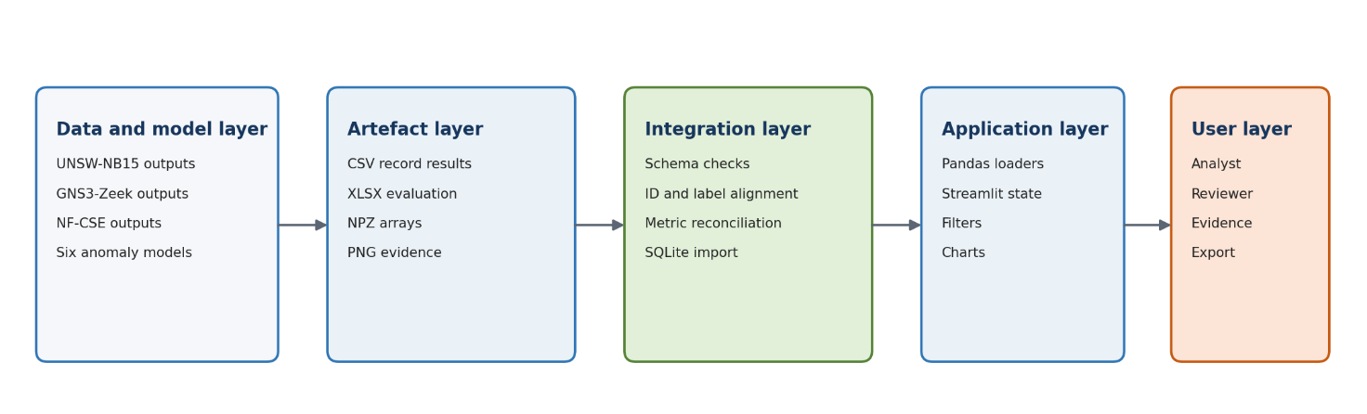Figure 1 Overall system architecture and the boundary between model computation and dashboard presentation

8 Data Flow Architecture
Record-level and aggregate information use separate flows. A record-level row represents one network observation, whereas an aggregate row represents one model or one model-budget pair. Keeping these layers separate prevents duplicated metrics and ambiguous joins.
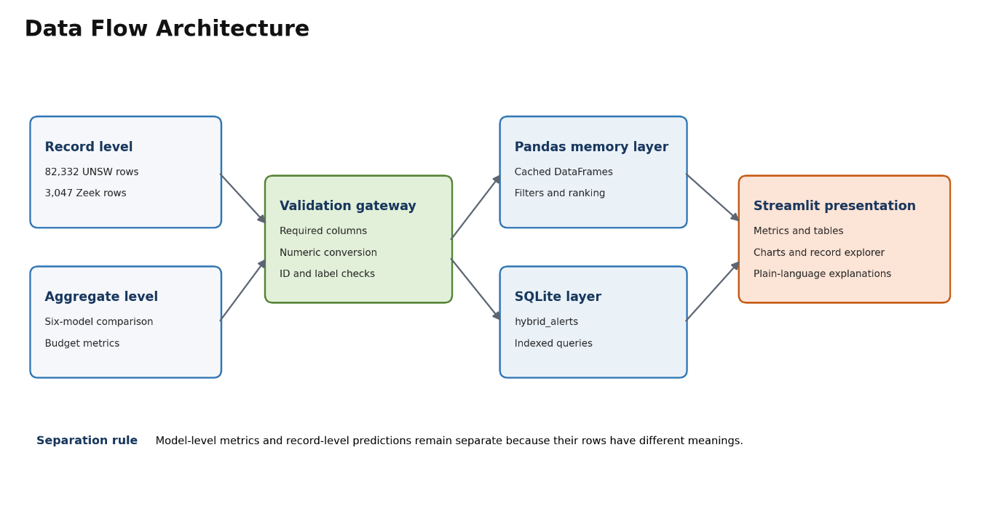

9 Model Integration Architecture
Six models expose different anomaly-score semantics. Integration therefore uses a canonical contract rather than forcing every model to use an identical internal algorithm. The contract standardises identity, truth, score, predictions, statuses and default operating point while preserving model-specific extension fields.

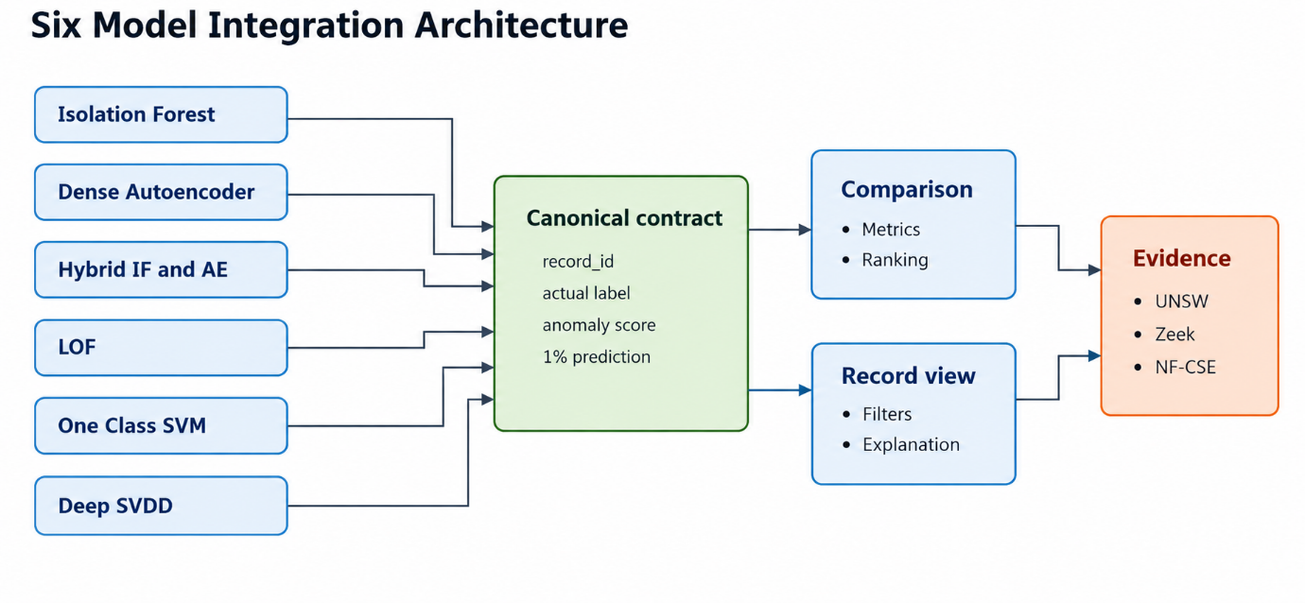

Figure 3 Six-model integration architecture and ownership boundary

10 Dashboard Technology Selection

10.1 Python
Python was selected because the model notebooks and exported data pipeline already use the Python data-science ecosystem. This avoids a second implementation language and allows consistent numeric handling across model and dashboard artefacts.

10.2 Streamlit
Streamlit was selected for rapid construction of an interactive technical prototype. It provides metric cards, sidebars, tabs, file upload, tables, charts and stateful widget reruns directly from Python. This was more appropriate than building and maintaining a separate JavaScript frontend and API for a university prototype. The limitation is that Streamlit's rerun model and local session management require careful caching and are not a replacement for a hardened multi-user SOC platform.

10.3 Pandas and NumPy
Pandas is used for structured CSV and Excel loading, numeric conversion, filtering, ranking and table preparation. NumPy arrays preserve compact six-model score and prediction evidence in the UNSW package. The final interface primarily reads DataFrames because their named columns improve traceability.

10.4 SQLite
SQLite was selected for the Hybrid demonstration because it provides persistent structured storage without requiring a separate database server. The hybrid_alerts table contains 82,332 records, and indexes support the filters used by the interface. SQLite is suitable for a local prototype but would need replacement or controlled deployment for concurrent production use.

10.5 CSV Excel NPZ and PNG
CSV is used for transparent record-level interchange, Excel for multiple related evaluation sheets, NPZ for compact numeric arrays and PNG for fixed evidence charts. Each format has one defined role. The dashboard does not treat a static chart as the source of numeric truth; charts remain supporting evidence while CSV and Excel hold the values.

11 Streamlit Dashboard Design
Every model-specific application follows the same execution pattern: configure the page, define the expected schema, locate a stable default file, offer a controlled upload fallback, load and validate the data, derive presentation fields, render metrics and filters, then explain a selected record. Repetition of this pattern is intentional because it makes the six pages predictable and easier to maintain.

REQUIRED_COLUMNS = {...}
default_csv = find_default_csv()
data_source = default_csv if default_csv is not None else uploaded_file
df = load_csv(data_source) # cached and schema checked
df['severity'] = ... # presentation-only priority
filtered = df[...] # status/class/ID filters
st.dataframe(filtered, ...) # inspectable evidence

11.1 Step 1 - define the dashboard contract
I began by separating model production from dashboard presentation. The notebook or final test owns training, preprocessing, scoring and threshold generation. The dashboard owns loading, validation, filtering, explanation and display. I wrote down the minimum fields required to cross this boundary: record identity, evaluation label, anomaly score, threshold, prediction, readable status and correctness. This prevented Streamlit from becoming a second, hidden implementation of the model.

11.2 Step 2 - inventory every supplied artefact
I opened each CSV and Excel sheet and inspected column names, row meaning, identifier range, missing values and data types. I also inspected NPZ array keys, PNG chart purpose and the Hybrid database schema. I recorded which file was authoritative for aggregate metrics, which file supported record exploration, and which was only supporting visual evidence. This step identified the incomplete earlier comparison file and the zero-based Hybrid identifiers before either could corrupt the final interface.

11.3 Step 3 - establish stable project paths
Each Python application derives its base directory from Path(__file__).resolve().parent. Source names are then joined to that base directory or to a controlled data subfolder. This design allows the whole project folder to move between computers without editing a personal C:\Users path. Model pages search a short ordered set of candidate locations; final-testing pages use fixed package files so that a demonstration always loads the same evidence.

11.4 Step 4 - validate before calculating
For each source I declared required columns and numeric columns. The loader first checks the file, then compares the supplied schema with REQUIRED_COLUMNS, converts numeric fields with pd.to_numeric and rejects missing mandatory values. Boolean correctness fields are normalised from supported representations. A failed validation calls st.error and st.stop, so no card, table or chart can be created from partial data.

11.5 Step 5 - align identifiers labels and score meaning
I compared row counts, unique identifiers and actual-label sequences across the UNSW exports. Five sources used IDs beginning at one and the Hybrid source used IDs beginning at zero, although their row order matched. I generated one canonical zero-based record_id only after verifying the label sequence. I also aligned anomaly-score direction: the One-Class SVM raw decision function was reversed before export, allowing every dashboard explanation to use the consistent rule that a larger displayed score is more anomalous.

11.6 Step 6 - create reusable cached loaders
CSV and Excel loading functions are decorated with Streamlit caching so a widget rerun does not repeatedly parse the same file. Each loader returns a validated DataFrame rather than an untyped raw object. Aggregate and record-level files use separate loaders because their row meanings differ. The large UNSW record file remains available for filtering, but only a limited preview is sent to the browser.

11.7 Step 7 - derive presentation fields without changing model evidence
The application adds fields only when they help presentation and can be reproduced from exported decisions. Severity is derived from the strictness of the 0.5%, 1% and 3% anomaly decisions; it is not written back as a model probability. Human-readable model names, formatted percentages and confusion labels are similarly presentation fields. Original scores, thresholds and predictions remain unchanged so that the interface can always be reconciled with the notebook output.

11.8 Step 8 - build controls around one shared state
I created sidebar selectors for model and validation budget and filters for status, severity, actual class and exact record ID where the source supports them. The same selected model and budget are used by metric cards, tables, charts and the explanation panel. This prevents a common integration error in which a chart uses one threshold while a text explanation uses another. Empty filter results are handled as a normal state and produce an informative message.

11.9 Step 9 - calculate and reconcile displayed metrics
The aggregate loaders convert precision, recall, F1, FPR, AUC and confusion counts to numeric values. I recomputed actual FPR as FP divided by FP plus TN and false alerts per 1,000 as FPR multiplied by 1,000. Rankings are created after validation, using F1 for the default order while separately identifying highest precision, lowest FPR and best PR-AUC. This prevents the dashboard from declaring one universal winner when operational objectives differ.

11.10 Step 10 - add faithful record explanations
For a selected record the explanation function reads the displayed model score, the selected threshold, the exported status and the derived review priority. It then describes the model-specific meaning: neighbourhood density for LOF, learned boundary for One-Class SVM or centre distance for Deep SVDD. The sentence ends with an explicit warning that the signal requires investigation. Autoencoder and Hybrid pages use their preserved reconstruction and component-agreement evidence rather than forcing the same explanation onto every model.

11.11 Step 11 - integrate dataset-specific final views
After the model pages were stable, I built three final-testing applications. UNSW-NB15 contains full aggregate, budget and record-level evidence, so it supports five analysis tabs. GNS3-Zeek adds scenario, time and address context from practical traffic. NF-CSE contains only aggregate comparison evidence, so its dashboard deliberately omits record exploration. The same visual language is used across all three, but functionality is limited to what each package can prove.

11.12 Step 12 - verify the complete path
Finally, I started each Streamlit application from the project directory and exercised every selector, filter and tab. I checked counts and predictions against their source files, tested missing columns and invalid IDs, and confirmed that cached reruns did not reload the data unnecessarily. This final verification connects implementation to the traceability and test sections later in the artefact.

12 User Interface Design
The interface applies progressive disclosure. Summary metrics and the principal comparison appear first; tabs and expanders reveal model detail, budget analysis, record inspection and evidence only when required. Sidebar controls remain stable across views. Tables use formatted units and descriptive labels, and the selected-record panel converts the numeric decision into a short explanation.
Severity uses Critical, High, Medium and Low to prioritise review, but it does not predict attack type. Actual class is labelled as evaluation-only. Colour and icons help scanning, but meaning is also conveyed through text so that the prototype does not depend on colour alone.

13 Dataset Upload and Input Module

13.1 Source provenance
The dashboard values were not manually typed. UNSW-NB15 model notebooks produced six model-specific exports containing record IDs, ground-truth labels, anomaly scores and threshold decisions. My LOF, One-Class SVM and Deep SVDD notebooks produced their own exports. Rubaiyat Karim supplied Isolation Forest, Dense Autoencoder and Hybrid IF+AE outputs, which I validated and integrated.
The UNSW final-testing package uses UNSW_Model_Comparison_1pct.csv for the six-row ranking, UNSW_Model_Evaluation.xlsx for the three validation budgets, UNSW_Record_Level_Predictions.csv for 82,332 record-level comparisons, UNSW_All_Model_Scores_Predictions.npz for consolidated arrays and two PNG charts as fixed evidence. The GNS3-Zeek package contains 3,047 record-level practical-traffic predictions, a multi-sheet workbook and two charts. NF-CSE provides a six-row aggregate comparison and performance chart but no record-level predictions.

13.2 File discovery
The model dashboards implement find_default_csv using Path(__file__).resolve().parent and a short ordered list of project-relative candidate locations. This supports a normal project layout while avoiding a machine-specific path such as C:\Users\... . If no candidate exists, the sidebar exposes st.file_uploader for a CSV. Final-testing dashboards use fixed files inside their own data directories because those packages are designed as reproducible demonstrations.

13.3 Schema and type validation
Each model dashboard declares REQUIRED_COLUMNS. load_csv reads the file, calculates the set difference between required and supplied columns, and raises a clear ValueError if anything is missing. Numeric fields are converted with pd.to_numeric. Boolean correctness values are normalised from True, False, 1 or 0. The UNSW comparison loader also rejects missing numeric metrics rather than silently ranking incomplete rows.

missing = REQUIRED_COLUMNS.difference(data.columns)
if missing:
raise ValueError('The CSV is missing required columns: ' + ...)
for column in numeric_columns:
data[column] = pd.to_numeric(data[column], errors='coerce'

13.4 Fail-closed behaviour
Loading is wrapped in try/except. An invalid source produces st.error and st.stop, so the remainder of the page cannot display misleading partial results. The UNSW final dashboard checks mandatory files with require_file before creating tabs. This is a reliability control rather than only a user-interface convenience.

14 Model Selection Module
The UNSW final dashboard builds its model selector from the validated comparison table. MODEL_COLUMNS maps each readable model name to its record-level score and prediction columns, while MODEL_EXPLANATIONS maps the same name to a plain-language description. Using one mapping prevents different tabs from spelling or selecting the model differently.
One-Class SVM additionally exposes a validation-budget selector. THRESHOLDS, STATUS_COLUMNS and PREDICTION_COLUMNS map the 0.5%, 1% and 3% choices to the correct exported decision fields. When the user changes the budget, the selected threshold, status, prediction, counts and explanation change together. LOF and Deep SVDD pages use the exported 1% default for the main view while retaining all three decisions for severity.

15 Anomaly Detection Results Module
After a successful load, the model pages calculate total records, anomaly and normal counts, threshold and offline accuracy. Filters are applied to a copy of the validated DataFrame. A record-ID text input is converted to an integer; invalid text produces a warning and an empty result rather than an exception.
The displayed table contains only decision-relevant columns: record ID, anomaly score, status, severity, actual class and correctness. This avoids exposing dozens of raw features in the main alert list. The selected-record area then shows the exact score-threshold comparison in prose.

16 Explainability Module

16.1 Threshold explanation
The build_explanation function extracts the selected score, threshold, status and severity, evaluates whether the score crossed the threshold and generates a model-specific statement. It ends with the caution that an anomaly is not automatically a confirmed cyberattack. This is decision-level explanation: it describes how an exported score and selected threshold yield the displayed status. It is not feature attribution, SHAP analysis, causal explanation, or evidence that a flagged flow is malicious.

16.2 Score direction
LOF and Deep SVDD exports are oriented so that higher values are more anomalous. The One-Class SVM notebook reverses the raw decision-function sign before export, so the dashboard also uses higher-is-more-anomalous. This transformation is stated explicitly because applying a common threshold rule without aligning score direction would invert decisions.

16.3 Severity logic
LOF and Deep SVDD severity is derived from the supplied budget predictions: a record crossing the strict 0.5% decision is Critical; one crossing 1% is High; one crossing only 3% is Medium; and a record crossing none is Low. OCSVM compares its score with the three notebook thresholds. Severity is a review priority, not an attack classification or calibrated probability.

16.4 Confusion outcomes
For offline evaluation, the interface can describe true positive, true negative, false positive and false negative outcomes. A false positive is a normal record flagged as anomalous; a false negative is an attack missed by the model. These outcomes connect model quality to operational workload and risk.

17 Reconstruction Error Visualisation
The Dense Autoencoder offers model-specific evidence that does not apply to all six models. Its export preserves the largest reconstruction-error features and error values for each record. The dashboard uses these supplied fields to explain which reconstructed inputs differed most from the learned normal pattern. It does not claim that a large error proves causality; it is evidence of mismatch within the Autoencoder.
The Hybrid view preserves the Autoencoder evidence while also showing Isolation Forest and combined decisions. This prevents the hybrid result from hiding the component signals that produced it.

18 Performance Metrics Visualisation
The six-model table is ranked by F1 because F1 balances precision and recall, but the interface does not present F1 as the only definition of a best model. Precision represents alert reliability; recall represents detected attacks; actual FPR and false alerts per 1,000 represent analyst workload; ROC-AUC and PR-AUC describe ranking performance across thresholds; and TN, FP, FN and TP preserve the underlying counts.
Model | Precision | Recall | F1 | Actual FPR | False alerts per 1000 | PR-AUC
Dense Autoencoder | 0.9364 | 0.6327 | 0.7552 | 5.27% | 52.68 | 0.9011
Hybrid IF+AE | 0.9440 | 0.6259 | 0.7527 | 4.55% | 45.51 | 0.9057
Isolation Forest | 0.9401 | 0.6171 | 0.7451 | 4.82% | 48.19 | 0.8974
Deep SVDD | 0.9274 | 0.5945 | 0.7246 | 5.70% | 57.00 | 0.8955
LOF | 0.9364 | 0.5227 | 0.6709 | 4.35% | 43.49 | 0.8887
One-Class SVM | 0.8939 | 0.3396 | 0.4922 | 4.94% | 49.41 | 0.8375

At the shared 1% validation budget, Dense Autoencoder has the highest F1, Hybrid IF+AE has the highest precision and PR-AUC, and LOF has the lowest actual FPR. The preferred model therefore depends on whether detection coverage, alert reliability or false-alert workload has priority. A 1% validation budget does not guarantee a 1% test FPR because the normal validation and test distributions differ.

19 Dashboard Implementation

19.1 LOF dashboard
app_lof.py locates lof_dashboard_results.csv, validates fourteen required fields, converts numeric and Boolean values, assigns severity from the three exported budget decisions and builds a threshold explanation. It provides filters for status, severity, actual class and exact record ID. The dashboard uses the 1% operating point as default while retaining the 0.5% and 3% decisions for prioritisation.

19.2 One-Class SVM dashboard
app_one_class_svm.py stores the three notebook thresholds in THRESHOLDS and maps every budget to its exported status and prediction columns. The selected budget controls the displayed threshold, status, prediction, counts, accuracy and explanation. The page states that the notebook reversed the raw decision-function sign, preventing an incorrect interpretation of negative values.

19.3 Deep SVDD dashboard
app_deep_svdd.py follows the shared validation and filtering pattern. Its explanation calls the score a distance from the learned normal centre and displays eight decimal places because the values can be small. Severity is derived from exported decisions rather than invented percentage bands.

19.4 Final model comparison
app_model_comparison.py validates twelve aggregate columns, converts every metric to numeric, rejects missing values, sorts by F1 and inserts a rank. It calculates the models with best F1, highest precision, lowest actual FPR and best PR-AUC, then provides separate charts for detection quality, AUC and operational false alerts.

19.5 UNSW final-testing dashboard
UNSW_Final_Dashboard/app.py defines fixed data files relative to the application, validates the comparison and budget schemas and caches the 82,332-row record file. Five tabs separate overall comparison, selected-model details, budget analysis, record exploration and technical evidence. A central MODEL_COLUMNS mapping connects the selected model to the correct score and prediction columns.
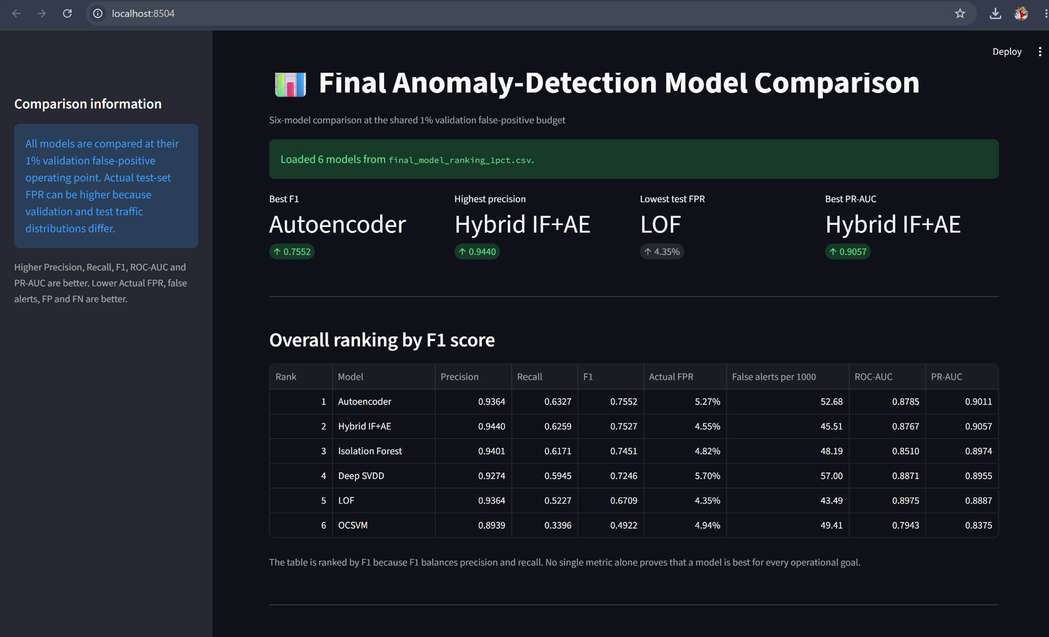
Figure 4 UNSW-NB15 final-testing dashboard

19.6 GNS3-Zeek final-testing dashboard

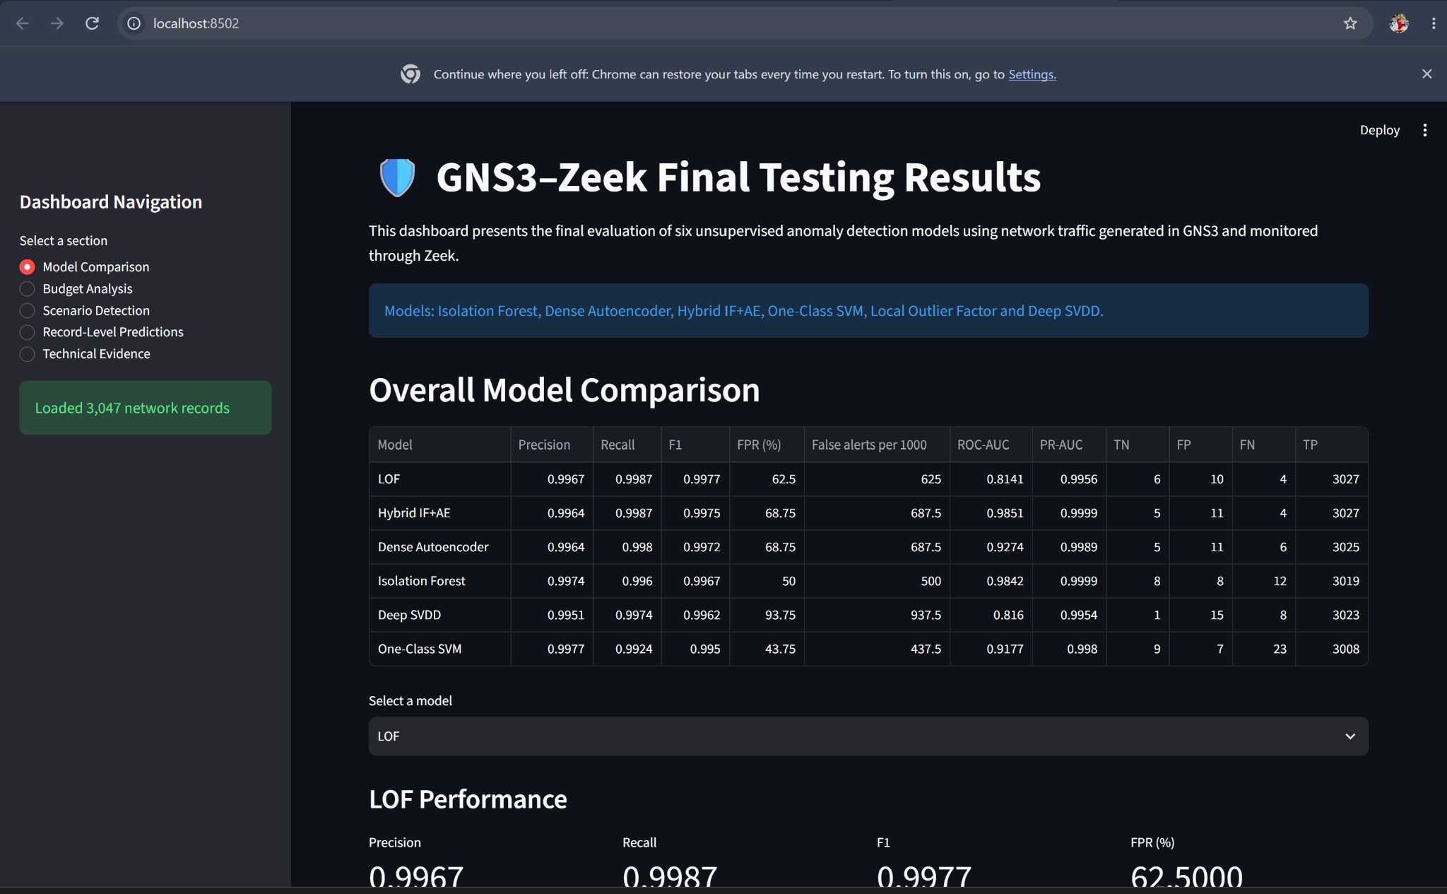
Figure 5 GNS3-Zeek final-testing dashboard
The GNS3-Zeek dashboard integrates a six-model workbook with 6,966 practical-traffic records. It preserves traffic type, timestamp, source and destination context, then separates comparison, budget, scenario, record and evidence views. Scenario detection includes bulk transfer, DNS burst, HTTP burst, ICMP burst, Nmap scan, normal traffic and failed SSH activity. The small number of normal records is stated as an evaluation limitation.
Evidence-population clarification: The original GNS3/Zeek frozen-threshold export evaluates 6,966 records, whereas the recalibrated analysis reserves 1,945 normal records for threshold setting and evaluates the remaining 5,021 records. These two reported evaluations are not identical held-out populations. Dashboard comparisons must display the source and count of the selected evidence file and must not describe changes in metrics as exclusively attributable to recalibration.

19.7 NF-CSE final-testing dashboard
The NF-CSE package contains aggregate comparison evidence but no record-level predictions. I therefore implemented comparison, selected-model, chart and evidence views without creating an unsupported record explorer. The page keeps the very high test false-positive rates visible and explains them as a threshold-transfer and dataset-distribution concern.
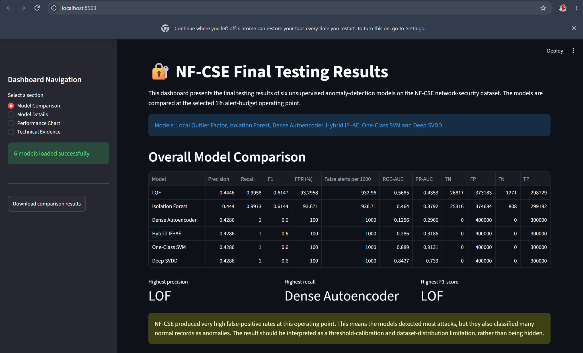
Figure 6 NF-CSE final-testing dashboard

19.8 SQLite-backed Hybrid implementation
The validated Hybrid CSV was imported into the hybrid_alerts table in alerts.db. The store contains 82,332 rows. Indexes on record ID, status and agreement support the dashboard queries. Agreement categories distinguish Both, IF only, AE only and Neither. Agreement adds review context; it is not a calibrated attack probability

20 End-to-End Prototype Integration

20.1 Canonical record contract
The six exports were integrated around common identity and decision fields: record_id, actual_label, actual_class, one model score, predictions and statuses at 0.5%, 1% and 3%, a default threshold, default prediction, default status and correctness. Autoencoder and Hybrid extension fields were preserved rather than discarded.

20.2 Record-ID correction
Five UNSW exports used record identifiers starting at one, while the Hybrid export used identifiers starting at zero. Joining those original identifiers directly would attach a model score to the wrong network row. I checked that each file had 82,332 unique records, compared the actual-label sequence with the base test set and confirmed that order was preserved. I then generated a common zero-based identifier from 0 to 82,331 for the consolidated record file.

20.3 Label and prediction preservation
Before consolidation, I checked row counts, unique identifiers, missing required values and label order. After consolidation, I compared each final default prediction array with its source export. This ensured that integration changed the identifier convention but did not change the model decisions.

20.4 Aggregate reconciliation
Aggregate metrics were checked against confusion counts. Actual FPR was recalculated as FP divided by FP plus TN, and false alerts per 1,000 as FPR multiplied by 1,000. This check detects percentage-versus-fraction errors and ensures that dashboard statements agree with the underlying counts.

21 Design Decisions and Alternatives Considered

21.1 Exported evidence instead of retraining in the page
Retraining when Streamlit opens would make the demonstration slow, introduce run-to-run variation and blur responsibility between model and dashboard code. I therefore selected exported evidence as the interface. Live inference is a later deployment objective.

21.2 Streamlit instead of a separate web stack
A React frontend and REST API would offer greater production control but would increase implementation and deployment complexity. Streamlit provides the interaction required for this prototype while keeping the data logic in Python. Its production limitations are recorded rather than ignored.

21.3 Separate model pages and one final comparison
A single generic page could hide score semantics and model-specific evidence. Separate pages preserve those differences; the comparison page provides consistency only at the shared metrics and canonical record fields.

21.4 SQLite for persistent demonstration storage
CSV was sufficient for most offline views. SQLite was added to demonstrate indexed persistent retrieval for Hybrid alerts. A server database was unnecessary for a local prototype but would be preferable for authenticated multi-user deployment.
Page

22 Dashboard and Integration Testing
Testing in this artefact is limited to my dashboard and integration responsibilities. It does not claim that I performed the training or scientific validation of all six models.

22.1 Functional Testing
I launched each available Streamlit application from the project directory, changed model and budget selectors, applied each filter, searched for exact record IDs and inspected the selected-record explanation. I tested result sets containing many rows, one row and no rows. Model counts, selected columns and explanations were checked after each control change.

22.2 Integration Testing
I verified 82,332 rows for each UNSW source export, unique identifiers, equivalent actual-label order and zero missing values in required fields. I confirmed that the final record-level predictions match the source default predictions and that the final comparison contains all six models. The incomplete four-model comparison was excluded.

22.3 System Testing
The reported manual offline integration test exercised the path from stored source artefacts to browser rendering. The dashboard application source and test logs were not supplied alongside this report for independent rerun; therefore this is documented developer test evidence rather than independently verified automated regression coverage. UNSW comparison, budget and record files were loaded together; the GNS3-Zeek workbook and record CSV were presented together; and NF-CSE correctly omitted unsupported record functionality. Missing files and malformed inputs stopped the relevant workflow.

22.4 Usability Testing
The interface was reviewed for readable labels, logical navigation, consistent model names, understandable metric definitions and explicit limitation text. A user can move from a high-level comparison to one model and then to one record without interpreting raw column names. The final Zoom demonstration sequence follows the same path.

22.5 Performance Testing
Caching was checked by changing widgets after the first file load; the application reused cached DataFrames rather than parsing each source again. The UNSW record preview is limited while the full match count is retained. Aggregate charts use six or eighteen rows instead of plotting all 82,332 records.

22.6 Security Testing
Input testing confirmed that only the expected structured file type is accepted by the model upload control, missing columns are rejected and invalid record IDs do not execute or alter queries. The local prototype uses no external model API. These checks do not replace a future production penetration test, access-control review or privacy assessment.

22.7 Test Cases and Results
Verification boundary: The pass entries in the following table are developer-reported manual checks documented in this artefact. Without dashboard source files, test transcripts or a clean rerun, this document does not independently establish automated test coverage, production-grade security, performance benchmarks or real-user usability testing. The claimed input-validation and SQLite functionality should be supported by the relevant project source files in the final archive.
Test | Expected result | Observed result
Valid model CSV | Load, validate and display records | Pass
Missing required column | Show controlled error and stop | Pass
Invalid record ID | Warn and return no matching row | Pass
Budget change in OCSVM | Threshold, decision and explanation update together | Pass
Six-model UNSW load | Six rows and 82,332 record-level entries | Pass
Prediction reconciliation | Final defaults equal source defaults | Pass
NF-CSE without record file | No unsupported record explorer | Pass
Cached rerun | Widget change without repeated file parsing | Pass

23 Requirements-to-Test Traceability
Each requirement was connected to at least one observable test. This prevents a requirement from being listed without evidence and keeps dashboard testing separate from model training tests.
Requirement group | Verification | Status
FR1-FR2 Input and schema | Valid, missing-file, missing-column and numeric-type tests | Satisfied
FR3-FR5 Comparison and metrics | Six-model load, format and confusion reconciliation | Satisfied
FR4 Controls | Model, budget, status, severity, class and ID interactions | Satisfied
FR6-FR7 Explainability | Selected score, threshold, severity, AE and Hybrid evidence review | Satisfied
FR8-FR9 Evidence and upload | Technical Evidence view and controlled upload fallback | Satisfied
NFR1-NFR5 Quality | Traceability, relative path, caching, error and limitation review | Satisfied for prototype

24 GitHub Implementation Evidence
Source-reference qualification: Some entries below are descriptive hyperlink labels rather than visible version-pinned file paths. Before final submission, verify that each hyperlink opens the intended file at the cited revision and that the archived source files match the demonstrated dashboard build. GitHub or README references alone are not execution evidence.
The following links connect the claims in this artefact to the version-controlled technical implementation.

24.1 Repository and dashboard documentation
Dashboard source folder: Open GitHub evidence — Contains the Streamlit applications, dashboard inputs, notebook evidence and screenshots used by the presentation layer.
Dashboard
README: https://github.com/Labannya22/COIT20265/blob/main/anomaly_detection_dashboard/README.md — Documents installation, Streamlit launch commands, SQLite creation, filters, severity, agreement and record-level explanation features.
Project requirements: https://github.com/Labannya22/COIT20265/blob/main/requirements.txt— Records the Python package dependencies required to reproduce the project environment.

24.2 Integrated dashboard and storage evidence
Isolation Forest dashboard: Isolation Forest Dashboard Code — Shows the integrated presentation code for the supplied Isolation Forest output.
Dense Autoencoder dashboard: Dense Autoencoder Dashboard Code — Shows reconstruction-error evidence and dashboard handling for the supplied Autoencoder output.
Hybrid dashboard: Hybrid IF+AE Dashboard Code — Combines Isolation Forest and Autoencoder outputs while preserving component status and agreement.
SQLite-backed Hybrid dashboard: SQLite Hybrid Dashboard Code — Demonstrates persistent indexed retrieval of integrated Hybrid alert records.
SQLite database creation: SQLite Database Integration Code — Creates and populates the hybrid_alerts table from the validated Hybrid result export.
Final comparison notebook: Final Six-Model Comparison Notebook — Produces the six-model comparison evidence used to interpret precision, recall, F1, FPR and AUC trade-offs.

24.3 Final-testing evidence
UNSW final evaluation: UNSW Final Evaluation Notebook — Evaluates all six frozen approaches on the held-out UNSW-NB15 test set.
GNS3-Zeek evaluation: GNS3-Zeek Evaluation Notebook — Evaluates the frozen models on practical GNS3 and Zeek traffic.
NF-CSE cross-dataset evaluation: NF-CSE Cross-Dataset Evaluation Notebook — Evaluates threshold transfer and distribution shift on NF-CSE-CIC-IDS2018-v2.

24.4 Dashboard screenshot evidence
UNSW dashboard screenshot: UNSW dashboard screenshot — Visual evidence of the completed UNSW final-testing interface.
GNS3-Zeek dashboard screenshot: GNS3-Zeek dashboard screenshot — Visual evidence of the completed practical-traffic interface.
NF-CSE dashboard screenshot: NF-CSE dashboard screenshot — Visual evidence of the completed cross-dataset interface.

25 Prototype Demonstration Results
The prototype successfully demonstrated the complete offline integration pathway. The UNSW dashboard displayed six models, three validation budgets and 82,332 record-level predictions. The GNS3-Zeek dashboard extended the interface to the documented 6,966-record frozen-threshold practical evaluation export with scenarios and network context. The NF-CSE dashboard presented the available aggregate evidence and openly communicated the high false-positive limitation.
During demonstration, a reviewer can begin with the UNSW comparison, identify the trade-off between F1 and FPR, select a model, change the operating budget, inspect a record and verify the supporting file. The same interface principles then transfer to GNS3-Zeek and NF-CSE without claiming that the three datasets provide identical evidence.

26 Overall System Performance Evaluation
The dashboard remains responsive because it loads aggregate tables separately, caches data and limits large previews. Operationally, the UNSW results show that no single model dominates every criterion. Dense Autoencoder provides the strongest F1, Hybrid IF+AE provides the highest precision and PR-AUC, and LOF provides the lowest actual FPR. One-Class SVM has the lowest recall at the selected operating point, while Deep SVDD provides stronger recall but a higher false-alert rate.
External-dataset results must be interpreted cautiously. GNS3-Zeek has a small normal subset, which makes FPR unstable. NF-CSE shows very high recall together with very high FPR, indicating that threshold transfer across data distributions is not reliable without recalibration. The dashboard adds value by making these weaknesses visible instead of selecting a winner from one metric.

27 Solution Evaluation Against Project Objectives
The prototype meets the project objective of presenting multiple unsupervised anomaly detectors in an inspectable interface. It integrates all six model outputs, enables comparison at a common operating budget, provides model and record explanations, demonstrates persistent storage and extends evaluation to practical and external data contexts.
The solution also meets the individual role objective: my work is identifiable through the three model implementations, model-specific applications, comparison dashboard, data-alignment logic, SQLite integration and three final-testing dashboards. The artefact preserves the boundary between my own model work and team inputs while demonstrating my responsibility for the complete presentation and integration layer.

28 Limitations and Future Development
The dashboards present offline exports and do not yet score live Zeek events.
Validation-budget thresholds require recalibration before deployment on a different network distribution.
The NF-CSE dashboard, as documented here, uses aggregate exported evidence rather than a validated record-level prediction source; consequently, it cannot offer defensible record-by-record explanations from the available dashboard input. This is a dashboard input limitation, not proof that the model-evaluation notebook never generated individual scores.
Local Streamlit execution has no production authentication, role-based access, audit logging or concurrency architecture.
Automated metadata, hash and regression checks should be added when source files are refreshed.

29 Conclusion
The dashboard prototype is an integration system, not only a collection of charts. I established a controlled interface between model outputs and Streamlit, corrected identifier inconsistencies, preserved model-specific evidence, reconciled aggregate metrics, connected SQLite storage and implemented dataset-appropriate final-testing views. The result allows an assessor to trace a displayed claim back to its source, understand how the code uses that source and see the limitations of the evidence.

References
Maspo, N.-A., Ghulam Hussain, M. T., Shafeeq Lone, A., & Mahmod Attar Bashi, Z. S. (2026). Anomaly detection of denial-of-service network traffic attacks using Autoencoders and Isolation Forest. International Journal on Perceptive and Cognitive Computing, 12(1), 145-151. https://doi.org/10.31436/ijpcc.v12i1.680
Cantone, M., Marrocco, C., & Bria, A. (2024). Machine learning in network intrusion detection: A cross-dataset generalization study. IEEE Access. https://doi.org/10.1109/ACCESS.2024.3472907
Kaya, M. O., Ozdem, M., & Das, R. (2025). A new hybrid approach combining GCN and LSTM for real-time anomaly detection from dynamic computer network data. Computer Networks, 268, 111372. https://doi.org/10.1016/j.comnet.2025.111372
Amaro, L. J. B., Azevedo, B. W. P., de Mendonca, F. L. L., Giozza, W. F., Albuquerque, R. de O., & García Villalba, L. J. (2022). Methodological framework to collect, process, analyze and visualize cyber threat intelligence data. Applied Sciences, 12(3), 1205. https://doi.org/10.3390/app12031205
Jiang, L., Jayatilaka, A., Nasim, M., Grobler, M., Zahedi, M., & Babar, M. A. (2022). Systematic literature review on cyber situational awareness visualizations. IEEE Access, 10, 57525-57554. https://doi.org/10.1109/ACCESS.2022.3178195
Vela Alonso, J. L., & Pellicer, C. (2026). Forensic-oriented intrusion detection using synthetic network traffic data and explainable artificial intelligence. arXiv:2607.00763. https://doi.org/10.48550/arXiv.2607.00763

